**Travel Policy for Leitrim PPN Public Participation Network 2024**

**Purpose:** Travel Policy for members conducting PPN business.

**Scope:** Secretariat Members & PPN Representatives.

**Policy and Procedures:** PPN Representatives (those representing the PPN on local decision-making structures) are entitled to make a request for travel for carrying out approved PPN business. Reimbursing Reps for travel while contributing their expertise and time to meetings, committees and training organised by Leitrim PPN is best practice.

PPN Reps that attend other PPN organised events or meetings not specifically organised for their attendance, cannot claim expenses.

A request for travel expenses can only be made when travel cannot be covered by another source (e.g., is not paid by the Board or Committee being attended by the Representative).

**What Travel is Eligible?**

* Such expenses will apply only for travel within the county for PPN secretariat meetings or outside the county in exceptional circumstances such as training, attending the PPN conference or Secretariat Network meetings.
* PPN Representatives on Local Authority Boards and Committees are reimbursed by the Local Authority, and not the PPN.
* Travel by PPN representatives to the Secretariat Meetings and any other events organised by the PPN or external organisation which Leitrim PPN wishes them to participate in. Car pooling must be the first option where feasible.

**Making Travel Claims:**

* Claims will only be made when payment of expenses cannot be covered by another source.
* Members must state the start and end point of each journey, the form of transport, and the purpose of the journey.
* Travel will be paid twice yearly only in June & December and if not claimed then it cannot be carried over to another year.
* Claims for travel will be processed through online banking only, you are required to provide bank account details.
* Leitrim PPN runs an annual budget and claims may only be made within the year they are incurred.
* Claims to be made on the official travel claims form only.

**Rates:**

* Mileage is available on round trips of 5km or more.
* The rates for travel payable by Leitrim PPN are as per public sector norms. These are currently:

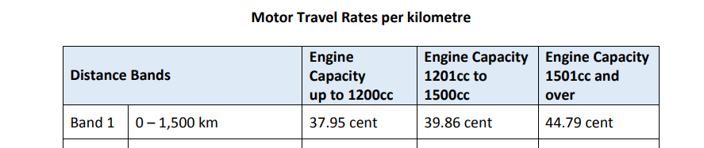



**Electric cars are claimed at the rates applicable to the 1201cc-1500cc engine. Hybrid cars are based on size of engine.**

**Authorising Claims:** Claims will be processed & authorised by Leitrim Development Company and cross referenced with meeting attendance records.

**Overnight expenses:** Leitrim PPN will not be paying overnight expenses for travel to any event unless an overnight stay has been approved in advance by the Secretariat.

*Updated March 2023*